GNDEC/TCC/ Dated: 22/01/2016

To

Mr. D K Taneja

Insurance Consultant,

M/s Maja Industries, Plot No. 160-161-162,

SICOP Industrial Estate, Kathua, J&K

**Sub: Inspection and testing report of fire affected building**

Sir,

On behalf of Consultancy Cell, GNDEC, Ludhiana, Dr. Jagbir Singh visited the above mentioned site on 02/12/2015 and did the required inspection in the presence of officials from the industry, namely Mr. Mohammad Athar, GM (Operations) and Mr. Jitendra Kumar, Factory Manager. Testing was done at various locations and samples of rebar and concrete were collected for further testing at our laboratory in Ludhiana. Following is the detailed test report:

.

1. **GENERAL INFORMATION**

The factory was constructed in the year 2009 and it produced mosquito repellant coils – which requires material and chemicals that are highly combustible like saw dust, coconut shell powder etc. The structure was a two-storey building frame system made up of concrete. The front portion of the building was used as office space, whereas the rear portion was the manufacturing unit. Fire broke out in the ground floor of the manufacturing area on 07/11/2015 at about 3:00 AM and the rear part of the structure collapsed within 5 to 6 hours there on. The front portion although didn’t collapse but was under severe distress with cracks and spalling of concrete at different locations.

1. **VISUAL / PHYSICAL EXAMINATION**

A detailed visual examination of the collapsed and un-collapsed portion of the structure was done and following are the related comments/observations along with photographs:

1. The intensity of fire in the rear portion of the building seemed to be very high, whereby high temperatures badly affected the capacities of both concrete and steel, which led to its ultimate collapse. The front portion of the building which didn’t bore the direct brunt of the fire – due to its insulation from the rear portion by brick wall – escaped the collapse but was subjected to stresses due to collapse of the adjacent portion, which led to development of widespread cracks in it, thereby making it unfit for its intended use.

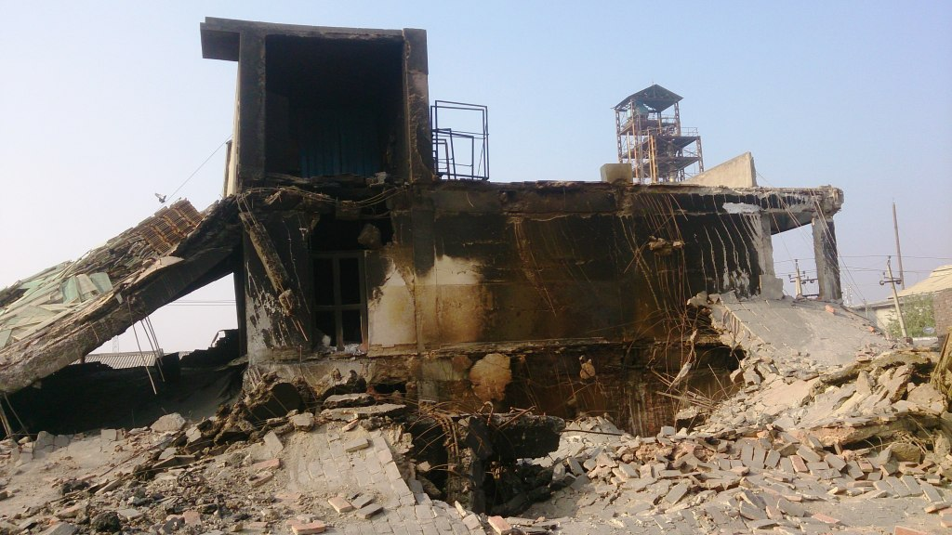

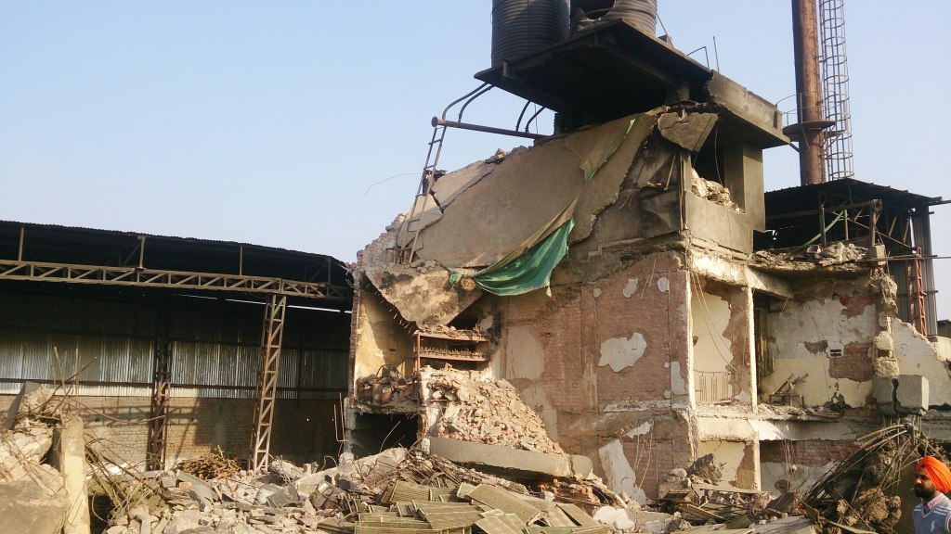

**Collapsed structure**

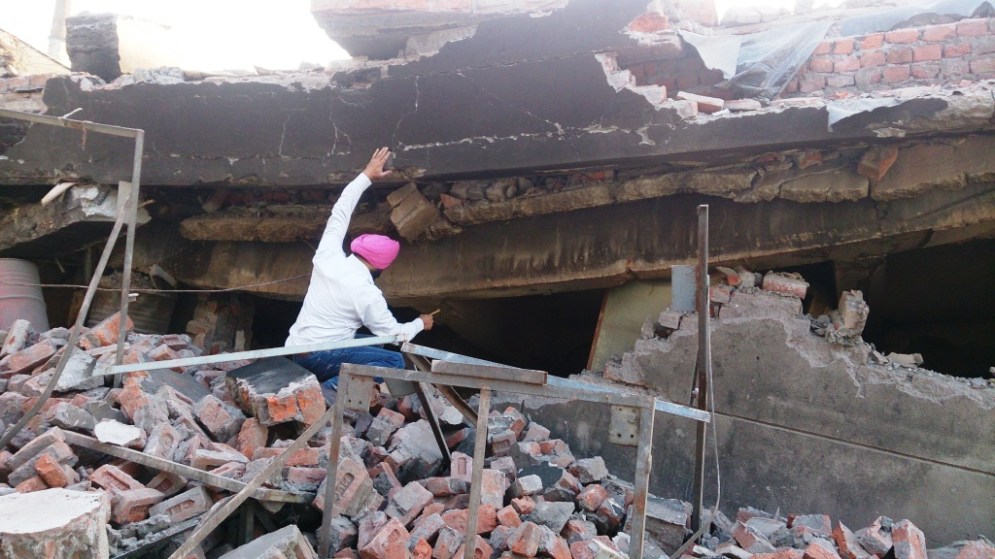

**FF Slab**

SF Slab

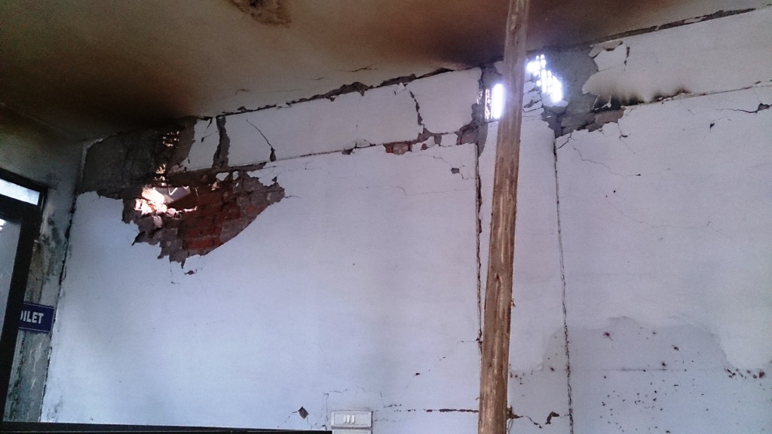

**Cracks and spalling of concrete in the front portion of the building**

1. The effect of fire and heat was evident everywhere on all components of the structure, whereby the colour of concrete had turned ‘ash grey’ and its texture had ‘softened’. Similarly, the rebars showed the sign of extreme heat as it had melted and cracked at some of the locations.

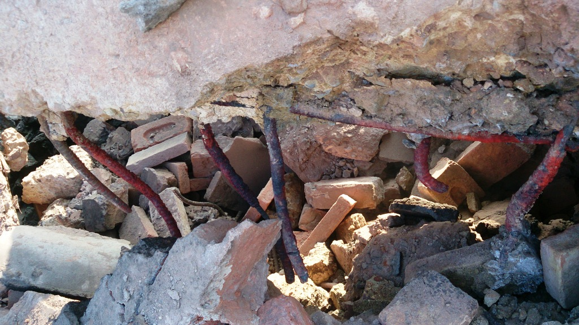

**Rebar melted**

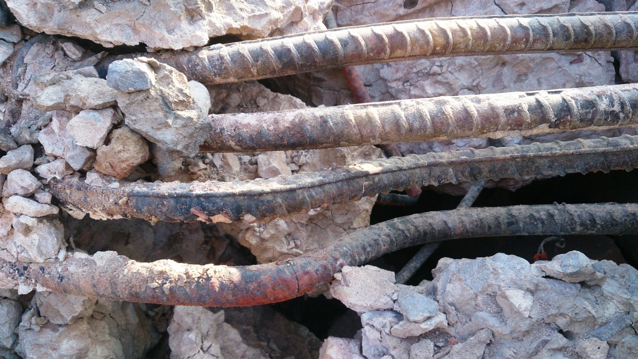

**Crack in Rebar**

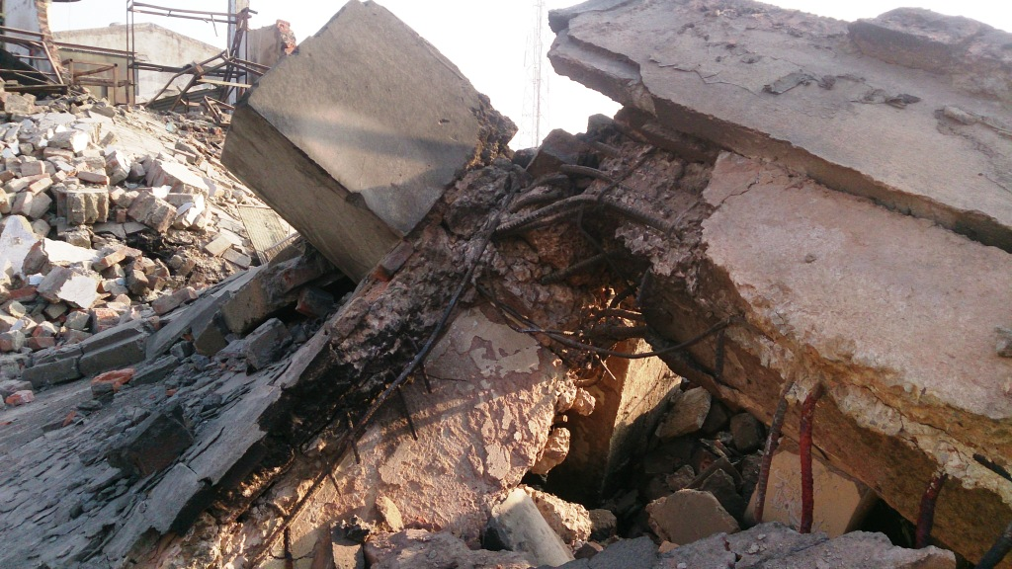

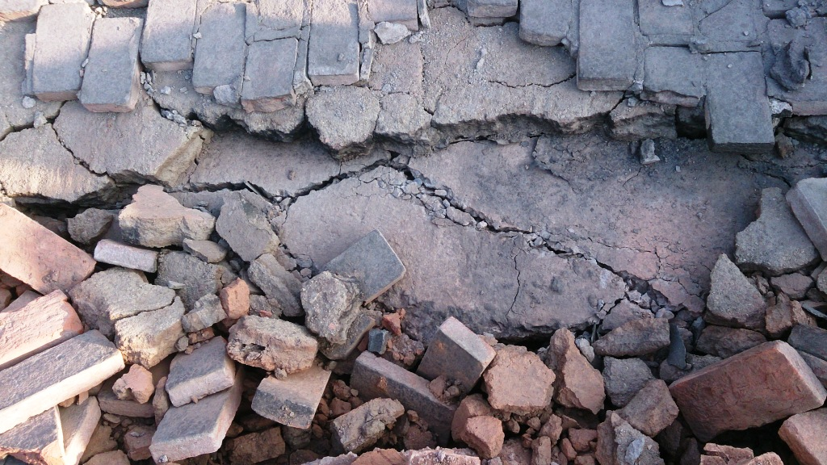

**Softened concrete in the slab**

1. **CONCRETE TESTING**
   1. **Core cutting test**

In the collapsed portion no other locations accept top of the second storey slab was safely accessible and thus it was decided to take concrete core samples from there. But, even after few tries at different places on the slab, no undamaged core sample could be obtained, because it was not possible to take out cores as concrete was soft and getting broken into small pieces during core cutting. This clearly indicated towards the effect of fire and heat on concrete quality. Concrete core samples were thereby collected only from the un-affected portion of the building to get an idea about quality of concrete as used in construction, and following are the test results of core samples taken from un-affected columns towards the front portion of the building:

|  |  |  |  |  |  |  |  |  |  |
| --- | --- | --- | --- | --- | --- | --- | --- | --- | --- |
| **Core No.** | **Height of Core ‘h’ (mm)** | **Diameter of Core ‘d’ (mm)** | **Weight of Core**  **(Kg)** | **Unit weight of concrete (Kg/m3)** | **h/d** | **Cross Secional Area of core (mm2)** | **Failure Load (N)** | **Comp. Str. of Core (MPa)** | **Equivalent Cube Comp. Str. (MPa)** |
| 1 | 61.00 | 45.40 | 0.216 | 2187.3 | 1.34 | 1619.48 | 10000 | 6.2 | **7.2** |
| 2 | 60.00 | 45.40 | 0.214 | 2203.2 | 1.32 | 1619.48 | 15300 | 9.4 | **11.0** |
| 3 | 63.40 | 45.40 | 0.230 | 2241.0 | 1.40 | 1619.48 | 11800 | 7.3 | **8.5** |

* 1. **Rebound hammer test**

As far as rebound hammer test was concerned, it was tried on damaged portion at different locations, but did not give valid results because the surface of the concrete had considerably softened. Thus, it was also conducted only on relatively un-affected portion of the building, and following are the test results as considered on un-affected columns towards the front portion of the building:

|  |  |
| --- | --- |
| **Location No.** | **Average Comp. Strength**  **(MPa)** |
| 1 | **10.5** |
| 2 | **16.0** |
| 3 | **14.5** |
| 4 | **13.0** |

1. **REBAR TESTING**

Rebar samples were checked and collected from site to ascertain their quality in the laboratory. These rebar samples did not contain any brand name – which is normally available on every single meter length – and thus did not indicate any information of their make. Reinforcement steel of “KAMDHENU” make was also used in construction.

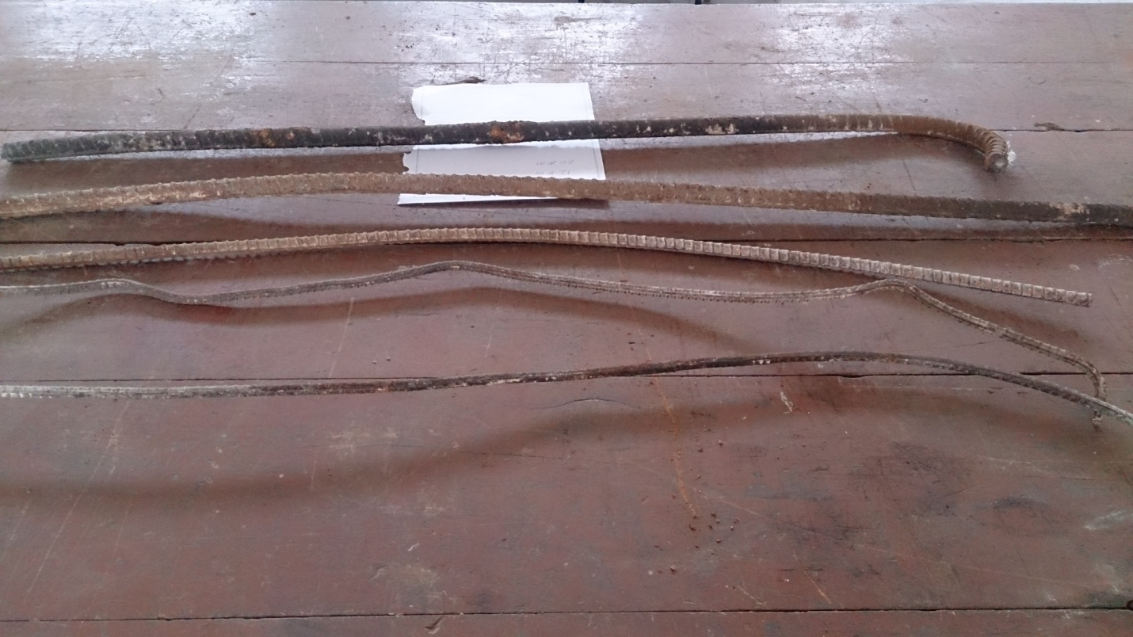

Following is the test report of various samples as collected from site (shown above), for which ‘make’ was unknown:

|  |  |  |  |  |  |  |  |
| --- | --- | --- | --- | --- | --- | --- | --- |
| **Diameter (mm)** | **Physical Testing** | | | | **Chemical Testing** | | |
| **Yield Str. (N/mm2)** | **Ultimate Str. (N/mm2)** | **Elongation (%)** | **Nominal mass**  **(Kg/m)** | **C** | **S** | **P** |
| 8 | 532 | 636 | 15.0 | 0.397 | 0.180 | 0.033 | 0.070* |
| 12 | 474 | 548 | 13.3* | - | 0.230 | 0.035 | 0.065* |
| 20 | 421 | 477* | 21.1 | 2.361* | 0.135 | 0.038 | 0.066* |

**NOTE:**

The values marked by star (*) do not meet the code specifications for reinforcement steel of grade Fe 415 – lowest available grade (IS 1786: 2008).

1. **CONCLUSIONS**
   * 1. Test results for concrete (Core cutting test, Rebound hammer test) indicate that the in-situ strength of un-affected concrete lies between 7.0 MPa and 16.0 MPa (considering test results of both the tests).
     2. Considering the reinforcement steel to be of lowest grade (Fe 415), the test results of rebars do not adhere completely to the corresponding code specifications for steel (IS 1786: 2008).

**(Dr. Jagbir Singh) Dean**

**(Testing & Consultancy)**