<http://www.facebook.com/groups/mailgndec/>

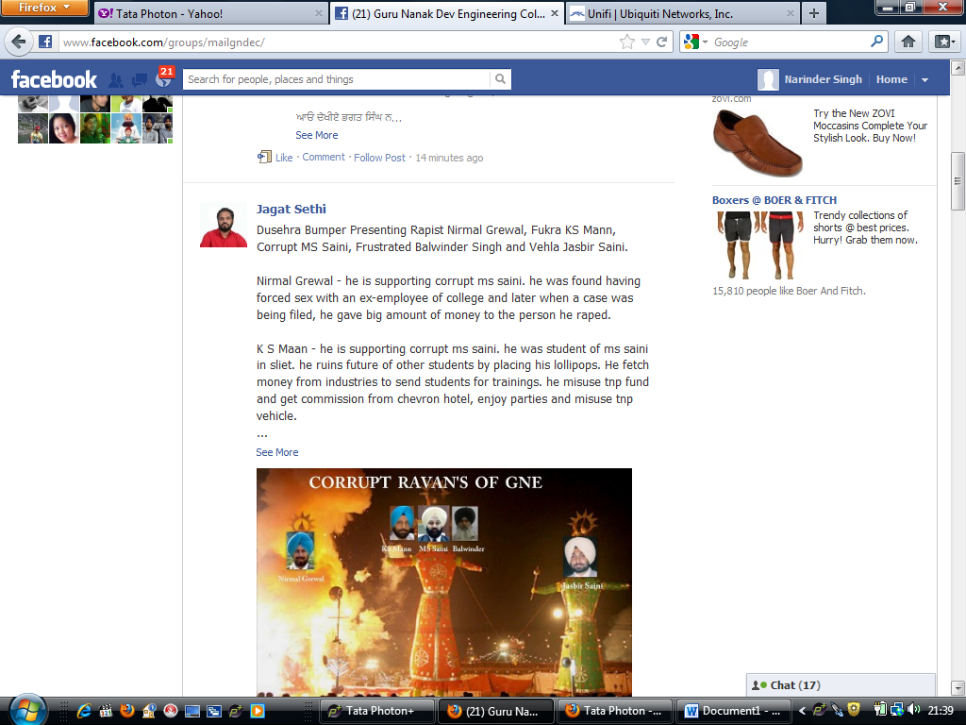

iiiiiiiii

<http://www.facebook.com/gndecludhiana?fref=ts>



iiiiii

<http://www.facebook.com/bittertruthh>



