mailgndec@groups.facebook.com
- Closed GroupClosed Group
- This group (GNDEC Ludhiana) is for people who graduated or post graduated or related to this college. Purpose of this gr...See More

  - Admins (4)
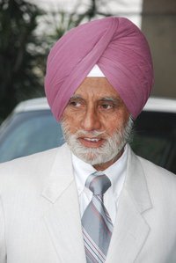  Joginder Singh Kular  Guru Nanak Dev Engineering College  Joined over a year ago |   Lovepreet Deol  Humber College  Added by Prabhjot Kaur about 7 months ago |   Gurmehar Singh  Guru Nanak Dev Engineering College, Ludhiana  Joined over a year ago


Manpreet Singh
GNDEC
Joined over a year ago

