• Sach Ka Saamna

Training & Placement Cell Part-3
TPC has been provided with Innova Car from TPC fund collected from students.
This vehicle is grossly misused by Director Saini and Dean KS Mann for personal visits. Vehicle being used for Bhog, Party, Airport duties and other household works. Shamelessly same written in log book. See entries in Log book. — with Gurdit Singh and 19 others.
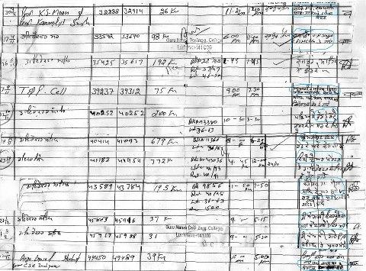

Like · · Follow Post · July 14 at 2:23pm

- Rajinder Ghai, Narinder Zaildaar, Komalpreet Singh Gill and 12 others like this.
- 
Darshan Dhillon Simran had look now let some one of your friends say it is fake go to college and check the log book and be sincere to report this on this page if it is true
July 28 at 9:17pm via mobile · Like · 3
- 
Komalpreet Singh Gill simran dhillon...just created his account 2 days ago(thursday)....lolzzz......nothing left to say
July 28 at 9:51pm · Like · 3
- 
Harpreet Singh Grewal Another member of fakie club...
July 29 at 12:43am via mobile · Like · 1
- 
Sach Ka Saamna Simran Gill and Neetu Gill are fake profiles of Jaspreet Sethi. Only one who is supporting M S Saini.
July 29 at 3:45am · Like · 1
- 
Gur Preet Hun eh vi dekho ihnu is Group ch add kihne kita ......?
July 29 at 7:55am via mobile · Like
- 
Er Jatinder Sekhon Saare chor ne..... Je support karni a ya against bolna himat karke apni profile ton bolo fake I'd wale fake lok.. Ik agla proof dinda uto chora di rai karn wale aa jande ne..
July 29 at 8:22am · Like
- 
Subhash Chander Sach Ka Saamna bhai RTI k through nikalwa lo details and publish it publically if it is true...sab kuch transparent ho jayega:D.Every 1 will get his doubts cleared..!!!
July 29 at 12:23pm · Like
- 
Sukhdev Singh Dear Subhash Chander ji all these pages are obtained under RTI only these are attested copies provided by college you can see college stamp also.
July 29 at 2:31pm · Like · 1
Subhash Chander aaj kal farzi farzi colleges me achi companies aati hain.. job fairs lagte hain,, why not in GNE,..shayad paise ghat ne colllege kol..
July 29 at 6:13pm · Like · 2
Darshan Dhillon Dear Kunwar Pal Singh it seems you have not read this post.It explains the state of things in TnP cell.Read the duties carried out by this vehicle in support of placement drives
October 17 at 1:06pm · Like
Darshan Dhillon Ho sakda ha daru da nasha na hove per official vehicle de log which aah duties bharna is definiitely showing the aatitude that "Jithe chahage Gadhi morrage nale signal toda ge"
October 19 at 6:01pm via mobile · Like · 1
- 
Lovepreet Deol nice song darshan sir lol
October 20 at 6:25am · Like
- 
Jagroop Singh Pandher eh 'sach da sahmana' koun hai ?? Veerji gal sach di krde o te khud da name real ni likhea
October 20 at 7:07am via mobile · Like
- 
Gurmehar Singh Jagroop Singh Pandher - actually this is a profile that provides evidence of corruption happening. since the fight is not personal, this profile is being used hence not being removed on humanitarian grounds.
October 20 at 7:29am · Like · 1
Jagroop Singh Pandher ok bro, fir thek a ,

•

Gurmehar Singh

I have made attempts to remove many fake profiles and photos as well. Please report if you encounter any.

Like · · Follow Post · October 18 at 9:51pm near Dallas, TX

- 2 people like this.
- 
Joginder Singh Kular Remove all who do not show their face.Some exception can be there for a genuine reason. I reject 1-2 requests to join the group everyday who don't disclose their true identity.
October 19 at 10:51am · Like · 2

• 

Manpreet Toor

Apne gndec girls hostel vich last month chori hoi c 4 kuria dae saman Di room vicho,oh chori MCA di ik kuri ne kiti c mein OS kuri da name nahi leana. kise v teacher ne os kuri upar koi action ne lea . asin kiran joti mam nu v keha c . ullta director sir ne 29 Sep nu 4 girls suspend kitia c 3 Oct tak jihna di chori hoi c ,jihne kiti c ohde upar koi action ne lea director sir ne . Hun apa nu youth nu ikathe ho k strike karni chahidi a . meri friends ne jihna Di room cho chori hoi c nale jihna nu suspend kita c ,Hun mein apni friends da kehn te tuhanu help lae keha meri friend ritu rajput te prattiba nu insaaf divauna . Hun apan sarea nu mil k gndec strike karni a ,Kyu k ehna ne Os MCA vali kuri upar koi action nahi lea

Like · · Follow Post · October 13 at 7:46pm via mobile

- Er Vivek Arora, Komalpreet Singh Gill, Avtar Badesha and 30 others like this.
- 2 of 86
View previous comments
- 
Grewal Harman Ranjit siyan, Tamana kaushal toon ki allo laine ne, Bibi ne message de dita apna hun jedi gall hundi hai oho karo. Gentlemen, it's confirmed that present students can't do anything for whatever reasons. Apan nu hi muree lagna paina, ek din bann lao po...See More
October 18 at 8:46pm · Like · 4
- 
Gagandeep Grewal 1993 wali vaddi strike vele, ikk landar kutta phar ke ohde gall vich takhti payi gai si, jis te likhia si "Vice Chancellor"..eho jahi kartootan de ba-vajood, mundian ne aapnia demands manvaa laiiyaan si..te odon PU si PTU nahi..
October 19 at 7:36am · Like · 3

Options
•

Sach Ka Saamna

Joke of decade
Read the comment by Jaspreet Sethi, partner of Corrupt M S Saini.
https://www.facebook.com/thebestjaspreet — with Yadwinder Dhillon and 23 others.
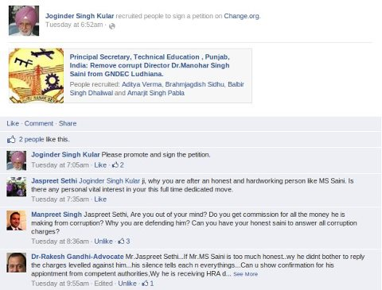

Sukhdev Singh Yar sethi saab ik change dost ne.Bahar bethe ve har kise nu phone karde ne.Hun lagda hi tronto ve jaan ge is parchar leye
October 17 at 1:15pm · Like · 1
Lovepreet Deol haha this sethi called me too..."why u r bothered about corruption , leave it, conc on ur career" etc etc...he is really some chaaploos of saini.
October 18 at 2:28pm · Edited · Like · 2

