Sach Ka Saamna

Another Cheap Act by Girls Hostel Warden and Chief Warden Jatinder Kapoor.
Aishwarya Jha www.facebook.com/aishwarya.jha1 First year CSE girl of our college was hospitalized in DMC ludhiana for 3 days due to migraine problem. When she was discharged from the hospital on Saturday around 6 in the evening, she requested college for ambulance, but she was declined by girls hostel warden. Warden ordered her not to enter the hostel until and unless she is 100% medically fit. If a person is discharged from hospital then she is obviously fit. But warden didn't even pay any heed to her parent's word, then they requested chief warden Jatinder Kapoor for help and he also refused rudely. The girl is from Andhra Pradesh so it wasn't possible for her parents to come immediately. So finally in name of humanity parents of girl begged the warden to allow her entry only for that night. This barbarism has to be stopped. Today its she, tomorrow it can be you. — with Mehboob Gill and 26 others.
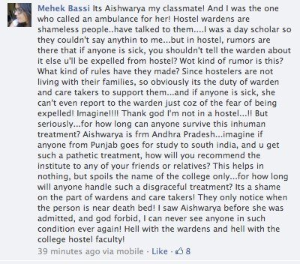

October 22 at 9:44pm

- Joginder Singh Kular and 9 others like this.
- 
Pushpinder Singh If true this is not done Hostel Warden is supposed to be the parent to the wards.
October 23 at 8:19pm · Like
- 
Sagardeep Singh shameless peoples

