**ABSTRACT**

Sustainable development in construction industry is aimed at improving the quality of life. It mainly depends on environmental, economic and social dimensions, as well as the concept of stewardship, the proper management of resources used in construction and particularly concrete production in India. As we know concrete occupies unique position among the modern construction materials. Concrete is a mixture of materials used in building construction, consisting of a hard, chemically inert particulate substance, known as aggregate (usually made for different types of sand and gravel), that are bonded together with cement and water. Concrete is normally used in the frame structure. But there is some limitation like compaction, surface finishes, maintaining strength at congested area. Due to these limitations we are trying to make self- compacting concrete with the use of mineral admixture.

Self-Compacting Concrete (SCC) is a special type of concrete that does not require any vibration for placing and compaction. It is capable of flowing under its own weight and completely filling formwork and achieving full compaction, even in the presence of congested reinforcement. Self-Compacting Concrete has properties that differ considerably from conventional concrete. This study investigates the workability and Compressive Strength properties of Self-Compacting Concrete containing Ground Granulated Blast Furnace Slag and Rice Husk Ash with super plasticizer and viscosity modifying agent. EUCOPLACANT 721 was used as super plasticizer and STRUCTRO 100 was used as Viscosity modifying agent. In this experimental program, trials were made at varying replacement levels (10%, 20%, 30% and 40%) of Ground Granulated Blast Furnace Slag and (5%, 10%, 15% and 20%) of Rice Husk Ash. The workability properties of SCC such as filling ability, passing ability and segregation resistance are evaluated using workability tests such as slump flow, V-funnel and L-Box tests. The compressive strength of the cubes at 7 days and 28 days are also obtained. The result obtained from the study proves that use of GGBS increases the Compressive strength of SCC by replacing cement to a percentage of 30% ,if the percentage is taken more than 30% the Compressive strength of SCC decreases. In case of GGBS and RHA combination the strength is highest by replacing cement with 5% of RHA and 30% of GGBS.

**CHAPTER-1**

**INTRODUCTION**

**1.1 HISTORICAL BACKGROUND**

During the beginning of 1983, the durability of concrete structures became a major topic of interest for the problem of failure of several construction works in Japan. Skilled workers are required for adequate compaction for the construction of durable concrete structures. But due to the gradual decrease in the number of skilled workers in Japan's construction industry also led to the decrease in strength of several construction works. This lead to the creation of Self Compacting Concrete, primarily through the work done by Japanese scientists Okamura and Ozawa(1995). The only solution of the problem of constructing durable concrete structures independent of the number of skilled workers was the use of concrete which can be compacted into every corner of a formwork, purely by means of its own weight and without skilled workers for providing vibrating compaction. The requirement of such type of concrete was first proposed by Ozawa and Okamura, (1995). For the study of various properties of Self-Compacting Concrete including its workability, a committee was formed which was led by Ozawa in 1989 at the University of Tokyo, Japan. Studies to develop Self-Compacting Concrete (SCC), including fundamental studies on the workability of concrete, had been carried out by Okamura and Ozawa at the University of Tokyo .The first useable version of SCC was developed in 1988 and was given the name “high performance concrete”, and later it was named as “self compacting concrete” (Seshadri and Srinivasa Rao, 2008).

**1.2 INTRODUCTION**

Concrete industry has made marvellous developments during the past 20 years. The development of concrete by specifying its use according to its performance requirements, rather than the constituents and ingredients has opened numerous opportunities for producers of concrete and consumers in designing Concrete structures to suit their specified requirements. The development of “Self-Compacting Concrete”(SCC) is one of the most outstanding accomplishments in the concrete technology during the last decade. Self Compacting Concrete as its name implies is a type of concrete which does not require any vibration to fill homogeneous voids of the structure. “Self-Compacting Concrete” (SCC) is a highly stable concrete which can flow readily into one place to another in the congested reinforcement under its own weight, filling formwork without any consolidation and significant segregation. The hardened concrete structures of SCC are homogeneous and dense and have engineering properties and durability as that of traditional normal vibrated concrete. However, the implementation of SCC eliminates the requirement of any type of compaction thereby reducing labour costs, saving time and conserving energy. Furthermore using SCC in concrete structures also enhances surface finish characteristics. Self-Compacting Concrete is mainly defined by two major properties. First is the ability to flow under its own weight and second is the ability to remain homogeneous during the flow. Flow ability of SCC is obtained by using high proportion of water reducing admixtures and segregation resistance is enabled by a chemical called viscosity modifying admixture.

Extensive studies had been done on the behaviour of Self-Compacting Concrete made with different combinations of materials and chemical admixtures. However, Limited studies were done on the behaviour of Self Compacting Concrete with use of by products like Ground Granulated Blast-furnace Slag (GGBS) and Rice Husk Ash (RHA) combination and its efficiency. Considering these gaps in present studies, we have an attempt has been made to investigate the strength efficiency of GGBS and RHA in SCC along with their Compressive strength and workability aspects. This study focuses on comparing Self-Compacting concrete containing different percentages of Rice Husk Ash and Ground Granulated Blast-Furnace Slag for different grades (i.e.M20, M30, M40) of concrete mixes.

As we know Rice Husk Ash is obtained by controlled burning of Rice Husk, which is generated in Rice milling industry. It has been found that Rice Husk Ash helps in the improvement of hardening properties and durability of concrete. Ground Granulated Blast-furnace Slag is a by-product obtained during extraction of iron from the ore by quenching molten iron slag from a blast furnace in water or stream to produce a glassy, granular product that is then allowed to be dried and later ground into a fine powder. Granulated Blast-furnace Slag makes the concrete more durable and provides strength over longer period of time. In this thesis work, we are trying to replace cement with Ground Granulated Blast-furnace Slag and Rice Husk Ash which are by-products of industrial and agricultural wastes. Because RHA and GBBS are dumped as a waste, If we use it as a cementation material the concrete becomes more sustainable and environmental friendly.

**1.3 ADVANTAGES OF SCC**

For several decades, Self-Compacting Concrete has been mentioned as one of the most revolutionary development in concrete industry. Originally developed due to the growing shortage of skilled labour, it has provided several benefits economically because of number of factors such as improved filling capacity in highly congested structural members:

1. Elimination of common defects such as honeycombs, cavities, excessive porosity etc.
2. Elimination of noise pollution caused by vibration.
3. Utilization of by products of industry like Fly Ash, GGBS and RHS in concrete to eliminate the environmental hazardous i.e. concrete becomes sustainable.
4. Improved health and safety at sight.
5. It can be used in multi-storey buildings by means of pumps.
6. Shortens construction period and less manpower.
7. Its finishing is better than ordinary concrete.
8. It is less porous than ordinary concrete.
9. It is more durable than ordinary concrete.
10. It has more alkaline resistance.

**1.4 SCOPE OF STUDY**

Over the past few years, the potential for the use of SCC in construction projects has been effectively demonstrated.SCC has been used in various construction projects. However, there has not been much use of industrial by-products like Fly Ash, Rice Husk Ash and Ground Granulated Blast-Furnace Slag in SCC for making the concrete products more durable, workable and Eco-friendly and several consumers of concrete are unaware of the new developments in concretes like special types of eco friendly concretes and its concepts. Various reasons for the use of GGBS and RHA are given below-

• The usability of secondary cementitious materials (SCMS) like RHA, GGBS etc in SCC to make the Concrete products more durable and sustainable and the scope for green products.

• To investigate the workability and compressive strength properties of GGBS and RHA based Self-Compacting concrete.

**CHAPTER 2**

**LITERATURE REVIEW**

**Arivalagan ,S.(2014)**: This study evaluates the strength efficiency factors of hardened concrete, by partially replacing cement by various percentages of ground granulated blast furnace slag for concrete of grade M35 at different ages. According this study, it can be concluded that, since the grain size of GGBS is less than that of ordinary Portland cement, hence its strength during the early days remains low, but it continues to gain strength over a long period. The optimum GGBS replacement as cementation material is characterized by better workability, good durability, high compressive strength, low heat of hydration, resistance to chemical attack, and cost-effectiveness.

**Ashwin, H.(2011)**: In this paper presents the comparative performance of Self-Compacting Concrete (SCC) manufactured with Fly ash (FA), GGBS based on fresh and mechanical properties. Seven concrete mixtures were investigated. FASCC mixture had cement replacement of 30%and 40%, while GGBS SCC mixtures had 30%, 40% replacement. Then Flyash is partial replaced by 50% Ground Granulated Blast Furnace Slag (GGBS), all these six mixtures is compared with Normal SCC (100% cement). The water – cementitious material ratio is 0.40. Tests were conducted on all mixtures to obtained fresh properties such as flowability, viscosity (assessed by rate of flow), and passing ability as well as hardened properties such as compressive strength, flexure strength, split tensile strength. The replacement of cement by percentages of FA or GGBS, influence of dosage of admixture on the properties of SCC was critically noted. The result obtained by the study shows that SCC with desired properties could be easily achieved by incorporating Fly Ash or GGBS in cement of SCC satisfying the target strength of 30MPa.

**Gadpalliwar.Sonali (2014)**: During this study, several effects of partially replacacing cement by GGBS is determined. They have stated that partial replacement of natural sand (NS) with Quarry sand and partial replacement of cement with GGBS and RHA can be an economic alternative. This research was carried out in three phase, in first phase mix of M40 grade concrete with replacement of 0%,15%,30%,45%,60%,75%,90% and 100% of quarry sand with natural sand is carried out to determine the optimum percentage of replacement at which maximum compressive strength was achieved. It was observed that when natural sand was partially replaced with 60% quarry sand maximum strength was achieved. In second phase, cement is partially replaced with GGBS by 10%, 20% and 30%. In phase three, combination of GGBS and RHA is partially replaced with cement. The composition of 22.5% GGBS + 7.5% RHA with 60% of quarry sand gives good strength results.

**Makul, Natt (2012)**: This investigation shows the effects on properties of Self-Compacting Concrete (SCC) mixtures containing rice husk ash (RHA) of varying percentages. Ordinary Portland cement (OPC) of grade 43 was partially replaced with Rice Husk Ash at different levels of 0%, 10%, 20%, or 40% of the total weight of the binder materials (OPC or RHA, 275, 325, or 375 kg/m3). The mixtures were adjusted in order to maintain a slump flow diameters of about 50 to 60 cm. The Rice Husk Ash used in this study was formed partially with amorphous silicon dioxide (SiO2) particles with an equivalent volume mean particle size of 24.32 μm. According to this study by increasing the Rice Husk Ash ratio results in decrease in unit weight and an increase in the corresponding water/binder ratio and T50 V-funnel times. Replacement of Rice Husk Ash with 20% of total cement produces a concrete mix with a long-term compressive strength.

**Opeyemi,D. and Makinde,O.( 2012)**: In this study, the various effects of replacement of cement by Rice Husk Ash and Bone Powder as a partial replacement for cement in concrete structures were noted. During this paper, the replacement of rise husk ash with cement varies from 5% to 20% in a concrete mix of 1:2:4. The Cubes casted and their results show that workability was consistent within the described values for lightweight concrete. Replacement of cement in the concrete mixture should not be more than 10% for producing the best results in the concrete production for concrete structures. The study proves that there is reduction in the total density of the concrete for 0 - 10% replacement of binding material, and the density increase with 10% - 20% replacement which shows that the unit weight of concrete gets reduced in the beginning which also leads to reduction in total self-weight of the structure.

**Turkel, S. and Kandemir, A. (2010)**: In this study, the effect of Self-Compacting Concrete with partial replacement of cement with Fly Ash and Limestone Powder are determined. As we know Self-Compacting Concrete (SCC) is a relatively new technology in the Concrete industry. Today, the development of Self-Compacting Concrete has becoming more popular due to its increased Durability and strength characteristics. However, the production of Self-Compacting Concrete requires more efficient workmanship and sensitive equipment. In addition to these there are other factor which effects the mechanical properties of Self-Compacting Concrete such as proportioning and curing, the origin of coarse aggregate and mineral admixtures. The effects of supplementary cementitious materials such Fly Ash and limestone powder on fresh and hardened properties of Self-Compacting Concrete have been studied in a series of various laboratory tests. The results so obtained shows that the effect of supplementary cementitious materials on fresh properties of SCC seems to have more dominant than the effect of aggregate type. Limestone powder and limestone aggregate combinations had superior fresh and mechanical properties compared to basalt-incorporated mixtures.

**CHAPTER – 3**

**PRESENT WORK**

**3.1 NEED OF STUDY**

Over the period of previous few years, the potential for use of SCC in concrete construction projects has been effectively demonstrated in some countries. In India the use of SCC is catching up and results have been encouraging. SCC has been used in various construction projects. However, Number of issues are needed to be addressed to make SCC vital to construction technology. So there is need to carry out research about various aspects of SCC including materials and mix design apart from its fluidity and strength characteristics.

**3.2 OBJECTIVES**

The primary objectives of this study are to optimize SCC mix and investigate its properties in green and hardened state, by making use of the Ground granulated blast-furnace slag(GGBS) and Rice Husk Ash(RHA) as a replacement of cement by varying proportion and to determine its effects on the fresh and hardened properties of SCC. The study also intends to quantify the amount of GGBS and RHA in SCC. The following are the main objectives that are being studied:-

* To develop a Self-Compacting Concrete of desired strength by making trials using GGBS and RHA.
* To investigate the compressive strength of Self-Compacting Concrete with GGBS and RHA for different grades of concrete with variable percentage at 7 and 28 days.
* To determine the percentage of GGBS and of GGBS and RHA combination for different grades of Self Compacting Concrete in which maximum Compressive strength can be obtained.
* To determine the Workability related characteristics of SCC by replacing cement with GGBS and RHA at different percentage.

**CHAPTER-4**

**EXPERIMENTATION**

**4.1 MATERIAL**

Various materials used in making of SCC in this study along with their properties are given below.

**4.1.1. CEMENT**

The cement used in this study is Ordinary Portland cement of Grade 43 of AMBUJA Cement, the physical properties and chemical compositions shown in tables 1 and 2

**Table 1.** Chemical properties of cement

|  |  |
| --- | --- |
| Chemical properties | Percentage% |
| Al2O3 | 6.1 |
| SiO2 | 23.3 |
| Fe2O3 | 4.7 |
| CaO | 64.6 |
| MgO | 1.7 |

**Table 2.** Physical Properties of cement

|  |  |
| --- | --- |
| Physical properties | Value |
| Initial setting | 75 (min) |
| Final setting | 215 (min) |
| Specific Gravity | 3.15 |

**4.1.2. FINE AGGREGATES**

Locally available sand (zone-II) conforming to IS: 383-1970 [6] specifications with fineness modulus of about 2.32 and specific gravity of about 2.66 were used as the fine aggregates in this concrete mix.

**4.1.3. COARSE AGGREGATES**

Machine crushed stones confirming to IS 383-1970 obtained locally were used as coarse aggregates in this study. The nominal sizes of coarse aggregates adopted in the present investigation were 20mm and 12.5mm. Fineness modulus and specific gravity of coarse aggregates used in this study were 6.86 and 2.67 respectively.

**4.1.4. GGBS (GROUND-GRANULATED BLAST FURNACE SLAG)**

Ground granulated blast furnace slag is a by-product of industrial wastes. It is obtained from the blast-furnaces which are used in making iron. The blast-furnace is heated at high temperature of nearly 1,5000 C and with controlled mixture of iron ore, coke and limestone are provided carefully to the furnace. The iron gets separated from the iron ore and the impurities get separated in the form of slag that floats on the surface of pure iron. The slag formed is taken out of the furnace in the form of molten liquid and it is then rapidly quenched in large volumes of water for the manufacture of GGBS. This process of quenching optimises the cementations a property of the slag and produces small granulates that are similar to coarse sand. The 'granulated' slag obtained is then allowed to dry and later grounded to a fine powder. The GGBS used to perform in this study was obtained from Nanda Construction Limited located in Karnataka. Chemical and physical proportion of GGBS is as shown in Table 3 and 4.

**Table 3.** Chemical Properties of GGBS

|  |  |
| --- | --- |
| Chemical Composition | Percentage % |
| CaO | 40% |
| SiO2 | 35% |
| AI2O3 | 10% |
| MgO | 8% |

|  |  |
| --- | --- |
| Characteristics | Test Results |
| Specific Gravity | 2.83 |
| Colour | Dull White |
| Standard Consistency | 36% |
| Fineness | *2.86* |

**Table 4.** Physical Properties of GGBS

**4.1.5. RHA (Rice Husk Ash)**

The Rice Husk Ash used in this study is also obtained from Nanda Construction Limited, Karnataka. Chemical analysis of RHA is summarized in Table 5

**Table 5.** Chemical Composition of RHA

|  |  |
| --- | --- |
| Consituents | Percentage% |
| Silicon dioxide (SiO2) | 91.2 |
| Aluminium oxide (Al2O3) | 0.94 |
| Magnesium oxide (MgO) | 0.88 |
| Calcium oxide (CaO) | 2.15 |
| Iron Oxide (Fe2O3) | 0.37 |

**4.1.6. SUPER PLASTICIZER (SP)**

Super Plasticizer (SP) is a chemical compound which is mainly used in Self-Compacting Concrete to increase the workability, without using any additional water. Super plasticizer used in this present work is a commercially available brand, EUCOPLACANT 721 obtained from FOSROC Chemicals (India) Pvt. Ltd, Bangalore.

EUCOPLACANT 721 is an admixture in that acts both as a highly efficient plasticizer and Water Proofing Compound. It is commonly recommended in the use of water retaining structures such as dams, reservoirs, sewerage works etc.

**4.1.7. VISCOSITY MODIFYING AGENT**

Viscosity Modifying Agent in this study STRUCTRO 100 was obtained from FOSROC Chemicals (India) Pvt. Ltd, Bangalore. It is a PCE based admixture specially developed by altering the molecular structures, grafting other polymers onto the basic trunk polymer and blending with other additional polymers. It is required to match special adjustments such as setting time, high slump retention and high water reduction.

**4.2 CONCTRETE MIX DESIGN**

Mehta in 1997 reported that for obtaining concrete of certain desired performance characteristics, the first step is the selection of components, the second step is a process called mix design by which the right composition of components is determined. Mix proportions are determined for the desired Workability of fresh concrete and after it gets hardened, it should require strength, durability and surface finish.

In general SCC shows high fluidity during its fresh state, its ability to flow under its own weight and segregation resistance all helps in reducing the risk of honeycombs formed in the concrete as per Chai (1998). Due to these good properties, the Self-Compacting Concrete thus produced greatly improves the durability of reinforced concrete structures. In addition to these, Self-Compacting Concrete also helps in increasing the strength during compressive strength test and can also achieve other construction requirements because its production can be taken into consideration for the requirements of structural design.

So far the proper mix design procedure to get the proportion of all the ingredients in the SCC is not standardised. No method specifies the grade of concrete in SCC except the Nan Su method. The limitation of Nan Su method is, that it gives required mix proportions for the grades which are more than 20N/mm2.

The standard mix design method of Self-Compacting Concrete was proposed by Japanese Mix Concrete Association in 1998 is a simplified version of Okamura (1995) method.

Based on the above method Concrete was prepared by using ratio of 1:2.35:2.4 for M20 grade, 1:1.32:1.68 for M30 grade and 1:1.2:1.36 for M40 grade with water cement ratio of 0.42. The various mix design are given in table 6 and table 7.

**Table 6.** Mix Design of SCC

|  |  |  |  |  |  |  |  |  |  |
| --- | --- | --- | --- | --- | --- | --- | --- | --- | --- |
| S.No. | Mix designation | Cement  Kg/m3 | Coarse Aggregate  Kg/m3 | Fine Aggregate Kg/m3 | GGBS Kg/m3 | RHA Kg/m3 | Water Kg/m3 | SP  % | VMA % |
| 1. | M20 | 390 | 936 | 916 | 0 | 0 | 220 | 0.68 | 0.07 |
| 2. | M30 | 430 | 695.92 | 887.17 | 0 | 0 | 235 | 0.84 | 0.07 |
| 3. | M40 | 475 | 708.8 | 812.8 | 0 | 0 | 215 | 0.68 | 0.07 |
| 4. | M20GGBS20 | 391.12 | 786.71 | 848.55 | 97.8 | 0 | 226 | 0.68 | 0.07 |
| 5. | M20GGBS30 | 342.3 | 785.43 | 850.53 | 146.8 | 0 | 226 | 0.68 | 0.07 |
| 6. | M20GGBS40 | 294.6 | 785.19 | 849.52 | 196.6 | 0 | 224 | 0.68 | 0.07 |
| 7. | M30GGBS20 | 424.4 | 698.2 | 888.17 | 106.2 | 0 | 225 | 0.84 | 0.08 |
| 8. | M30GGBS30 | 372.3 | 697.46 | 887.9 | 159.9 | 0 | 229 | 0.84 | 0.08 |
| 9. | M30GGBS40 | 319.80 | 696.16 | 889.6 | 213.2 | 0 | 226 | 0.84 | 0.08 |
| 10. | M40GGBS20 | 471.4 | 710.41 | 813.85 | 118.6 | 0 | 219 | 0.68 | 0.07 |
| 11. | M40GGBS30 | 412.6 | 709.56 | 812.91 | 177.4 | 0 | 217 | 0.68 | 0.07 |
| 12. | M40GGBS40 | 354.2 | 708.9 | 814.17 | 235.8 | 0 | 220 | 0.68 | 0.07 |
| 13. | M20GGBS30RHA5 | 342.1 | 785.45 | 849.6 | 122.25 | 25.25 | 222 | 0.68 | 0.07 |
| 14. | M20GGBS30RHA10 | 344.6 | 786.34 | 850.1 | 98.14 | 49.50 | 224 | 0.68 | 0.07 |
| 15. | M20GGBS30RHA15 | 343.8 | 784.85 | 848.9 | 73.75 | 73.45 | 223 | 0.68 | 0.07 |
| 16. | M20GGBS30RHA20 | 342.5 | 785.76 | 847.6 | 79.50 | 98.28 | 225 | 0.68 | 0.07 |
| 17. | M30GGBS30RHA5 | 374.2 | 696.76 | 889.1 | 132.9 | 22.65 | 227 | 0.84 | 0.08 |
| 18. | M30GGBS30RHA10 | 473.9 | 697.98 | 888.44 | 107.12 | 36.6 | 228 | 0.84 | 0.08 |
| 19. | M30GGBS30RHA15 | 474.1 | 696.75 | 890.36 | 79.95 | 53.14 | 226 | 0.84 | 0.08 |
| 20. | M30GGBS30RHA20 | 472.9 | 697.87 | 889.88 | 53.3 | 70.6 | 227 | 0.68 | 0.07 |
| 21. | M40GGBS30RHA 5 | 414.7 | 710.43 | 813.85 | 147.75 | 22.14 | 218 | 0.68 | 0.07 |
| 22. | M40GGBS30RHA10 | 413.1 | 709.75 | 814.41 | 118.6 | 44.4 | 216 | 0.68 | 0.07 |
| 23. | M40GGBS30RHA15 | 412.6 | 710.56 | 812.92 | 89.54 | 67.48 | 220 | 0.68 | 0.07 |
| 24. | M40GGBS30RHA20 | 414.7 | 711.23 | 814.24 | 59.6 | 88.82 | 218 | 0.84 | 0.08 |

**Table 7.** Percentage of Mix Design

|  |  |  |  |  |  |  |
| --- | --- | --- | --- | --- | --- | --- |
| S.No | Mix designation | Percentage of Cement(%) | Percentage of binder ratio (%) | | Percentage of Admixtures(%) | |
| GGBS | RHA | SP | VMA |
| 1. | M20GGBS20 | 80 | 20 | 0 | 0.68 | 0.07 |
| 2. | M20GGBS30 | 70 | 30 | 0 | 0.68 | 0.07 |
| 3. | M20GGBS40 | 60 | 40 | 0 | 0.68 | 0.07 |
| 4. | M30GGBS20 | 80 | 20 | 0 | 0.84 | 0.08 |
| 5. | M30GGBS30 | 70 | 30 | 0 | 0.84 | 0.08 |
| 6. | M30GGBS40 | 60 | 40 | 0 | 0.84 | 0.08 |
| 7. | M40GGBS20 | 80 | 20 | 0 | 0.68 | 0.07 |
| 8. | M40GGBS40 | 70 | 30 | 0 | 0.68 | 0.07 |
| 9. | M40GGBS40 | 60 | 40 | 0 | 0.68 | 0.07 |
| 10. | M20GGBS30RHA5 | 70 | 25 | 5 | 0.68 | 0.07 |
| 11. | M20GGBS30RHA 10 | 70 | 20 | 10 | 0.68 | 0.07 |
| 12. | M20GGBS30RHA15 | 70 | 15 | 15 | 0.68 | 0.07 |
| 13. | M20GGBS30RHA20 | 70 | 10 | 20 | 0.68 | 0.07 |
| 14. | M30GGBS30RHA5 | 70 | 25 | 5 | 0.84 | 0.08 |
| 15. | M30GGBS30RHA10 | 70 | 20 | 10 | 0.84 | 0.08 |
| 17. | M30GGBS30RHA15 | 70 | 15 | 15 | 0.84 | 0.08 |
| 18. | M30GGBS30RHA20 | 70 | 10 | 20 | 0.68 | 0.07 |
| 19. | M40GGBS30RHA 5 | 70 | 25 | 5 | 0.68 | 0.07 |
| 20. | M40GGBS30RHA10 | 70 | 20 | 10 | 0.68 | 0.07 |
| 21. | M40GGBS30RHA15 | 70 | 15 | 15 | 0.68 | 0.07 |
| 22. | M40GGBS30RHA20 | 70 | 10 | 20 | 0.84 | 0.08 |

**4.3 Experiment Methods**

**4.3.1 Durability Test**

Self-Compacting Concrete is generally defined by its filling ability, passing ability and segregation resistance. Several methods have been studied to characterize the properties of Self-Compacting Concrete. Until now there is no single method that characterizes every workability aspects, therefore, every mix has to be tested by more than one test methods for all relevant workability parameters. Table 8 gives the values that are recommended for different tests given by different researchers for making a mix that can be characterized as Self-Compacting Concrete mix.

**Table 8.** Recommended values for Different Properties of SCC

|  |  |  |
| --- | --- | --- |
| **Sr. No.** | **Test** | **Range** |
| 1. | Slump Flow Test | 500-700 mm |
| 2. | V-funnel Test | 6-12 sec |
| 3. | L-Box Test | ≥ 0.8 |

The first test that is conducted during durability test is slump flow test which is used to determine the flow ability of Self-Compacting Concrete by allowing the Self-Compacting Concrete to flow horizontally in the absence of any obstructions. By lifting the slump cone filled with concrete allowing the concrete flow downwards freely. The average diameter of the concrete circle formed after removal of slump cone is the measure for the filling ability of the concrete.

The V-funnel test is used to determine the flow ability of the fresh concrete, where the flow time of the concrete is measured, figure 1.The funnel used in this test is V-shaped and is completely filled with about 12 litres of concrete and total time taken by the concrete to flow through the apparatus is measured. Further, T5min is also measured in V-funnel test, which indicates the tendency for segregation in the concrete, where the funnel can be refilled with concrete and left for 5 minutes to settle. If the concrete shows segregation, then the flow time of concrete will also increase significantly.

The L- box test is used to determine the passing ability of the concrete as shown in Fig 2. The vertical section of the L-Box is to be filled with concrete, and then the gate lifted to allow the concrete flow freely to the horizontal section. The height of the concrete at the end of the horizontal section (H1) is taken proportional to the remaining height of the vertical section (H2) i.e. (H 2/H1). This is an indication of passing ability. The specified ratio of the height between the two ends or its blocking ratio is to be ≥ 0.8 for concrete

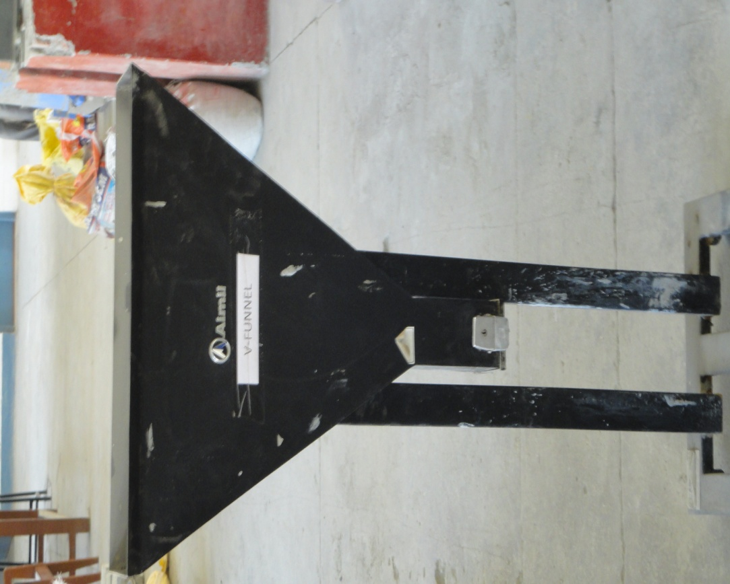

**Figure 1**

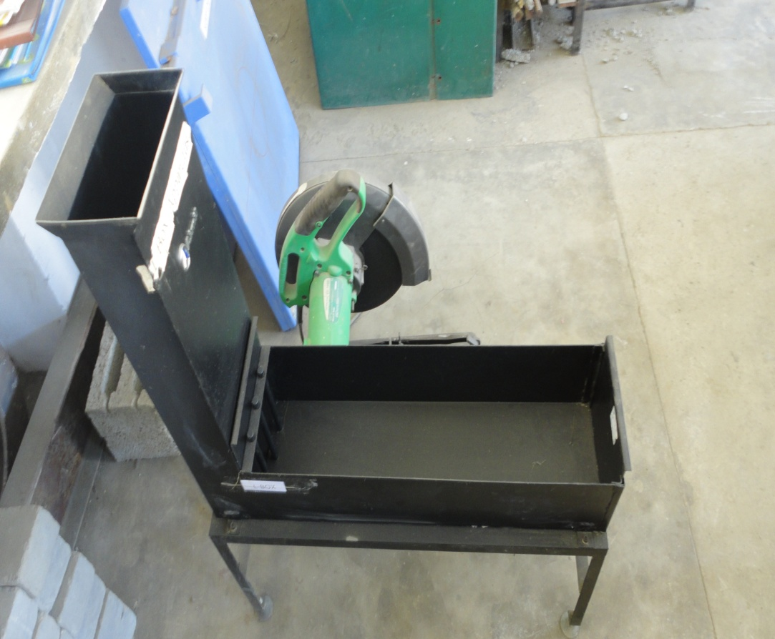

**Figure 2**

**4.3.2. COMPRESSIVE STRENGTH TEST**

The test to determine the compressive strength of concrete has been conducted according to specifications as per IS 516(1959). Test cubes of size (15×15×15) cm were used in lab. The SCC mix is casted in the cubes for about 24 hours. Then the specimens are taken out of the cubes and are cured in a water tank until they have been tested. The compressive strength of specimens are then determined using universal testing machine. The compressive strength is taken as average of specimen cubes after a peroid of about 7 and 28 days. After 7 and 28 days of curing, these cubes have been tested on digital compression testing machine specified as per I.S. 516(1959). The failure load gets noted during the test. Figure 3 shows the image of Digital Compression Testing Machine.

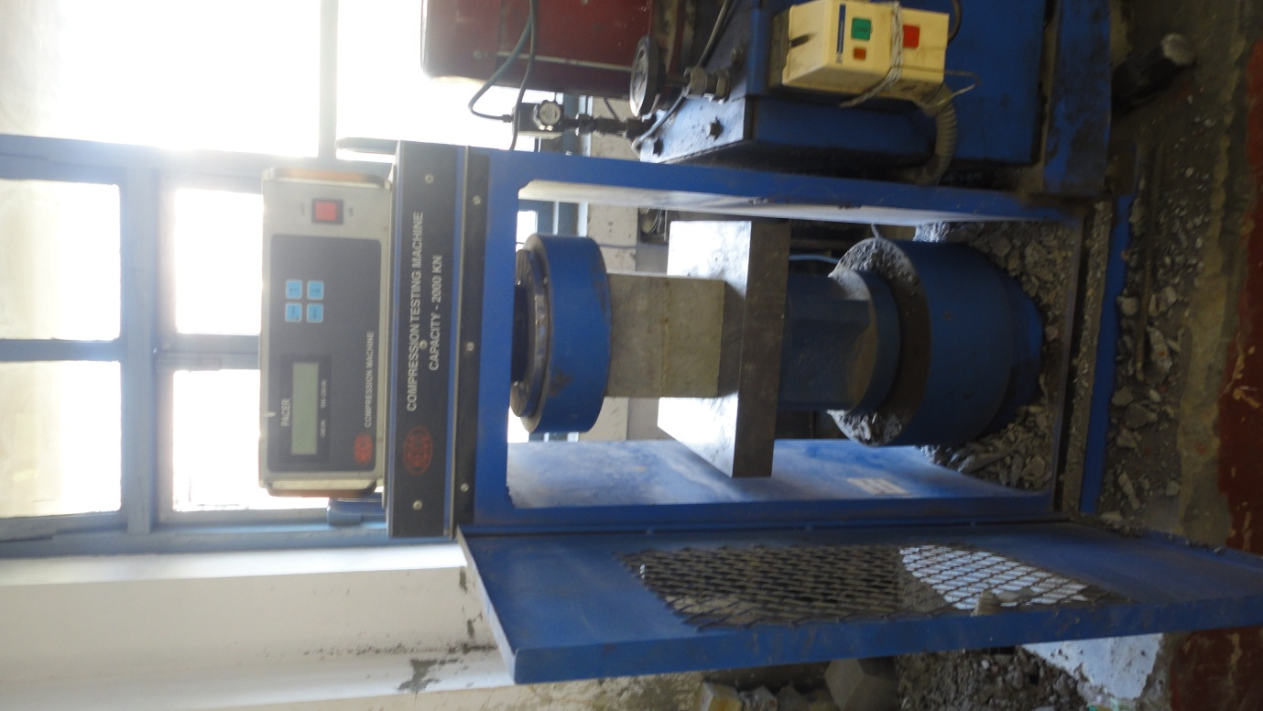

**CHAPTER-5**

**EXPERIMENTATION**

**5. RESULT**

**5.1. PROPERTIES OF SOFT CONCRETE**

|  |  |  |  |  |
| --- | --- | --- | --- | --- |
| S.No | Mix designation | Slump Flow Test (mm) | V-Funnel Test(sec) | L-Box Test |
| 1. | M20GGBS20 | 675 | 10.9 | 0.925 |
| 2. | M20GGBS30 | 685 | 10.2 | 0.931 |
| 3. | M20GGBS40 | 681 | 9.8 | 0.929 |
| 4. | M30GGBS20 | 685 | 11.2 | 0.928 |
| 5. | M30GGBS30 | 683 | 10.6 | 0.935 |
| 6. | M30GGBS40 | 679 | 10 | 0.631 |
| 7. | M40GGBS20 | 676 | 11.4 | 0.926 |
| 8. | M40GGBS30 | 684 | 10.8 | 0.932 |
| 9. | M40GGBS40 | 679 | 9.6 | 0.930 |
| 10. | M20GGBS30RHA5 | 682 | 11.4 | 0.934 |
| 11. | M20GGBS30RHA10 | 680 | 10.6 | 0.932 |
| 12. | M20GGBS30RHA15 | 676 | 10.2 | 0.929 |
| 13. | M20GGBS30RHA20 | 669 | 9.4 | 0.925 |
| 14. | M30GGBS30RHA5 | 688 | 10.5 | 0.932 |
| 15. | M30GGBS30RHA10 | 682 | 9.8 | 0.929 |
| 16. | M30GGBS30RHA15 | 680 | 10 | 0.927 |
| 17. | M30GGBS30RHA20 | 677 | 10 | 0.925 |
| 18. | M40GGBS30RHA5 | 672 | 11.1 | 0.934 |
| 19. | M40GGBS30RHA10 | 670 | 10.9 | 0.929 |
| 20. | M40GGBS30RHA15 | 665 | 10.2 | 0.932 |
| 21. | M40GGBS30RHA20 | 662 | 9.8 | 0.930 |

**5.2. PROPERTIES OF HARDENED CONCRETE**

|  |  |  |  |
| --- | --- | --- | --- |
| S.No | Mix designation | Compressive strength after 7 days (Mpa) | Compressive strength after 28 days (Mpa) |
| 1. | M20 | 22.20 | 41.2 |
| 2. | M30 | 32.5 | 58.25 |
| 3. | M40 | 39.97 | 65.52 |
| 4. | M20GGBS20 | 16.13 | 27.57 |
| 5. | M20GGBS30 | 17.3 | 31.54 |
| 6. | M20GGBS40 | 16.15 | 29.21 |
| 7. | M30GGBS20 | 19.89 | 35.68 |
| 8. | M30GGBS30 | 21.6 | 36.0 |
| 9. | M30GGBS40 | 19.93 | 31.11 |
| 10. | M40GGBS20 | 21.44 | 36.23 |
| 11. | M40GGBS30 | 22.16 | 40.80 |
| 12. | M40GGBS40 | 21.89 | 38.60 |
| 13. | M20GGBS30RHA5 | 24.16 | 44.67 |
| 14. | M20GGBS30RHA10 | 23.70 | 42.60 |
| 15. | M20GGBS30RHA15 | 23.19 | 40.80 |
| 16. | M20GGBS30RHA20 | 22,34 | 39.80 |
| 17. | M30GGBS30RHA5 | 23.80 | 43.10 |
| 18. | M30GGBS30RHA10 | 22.20 | 42.88 |
| 19. | M30GGBS30RHA15 | 20.90 | 41.72 |
| 20. | M30GGBS30RHA20 | 19.40 | 40.57 |
| 21. | M40GGBS30RHA5 | 25.29 | 42.13 |
| 22. | M40GGBS30RHA10 | 24.26 | 39.2 |
| 23. | M40GGBS30RHA15 | 22.18 | 39.16 |
| 24. | M40GGBS30RHA20 | 21.6 | 38.4 |

**CHAPTER 6**

**CONCLUSION**

**6.1. Conclusion**

* The addition of Ground Granulated Blast-furnace Slag and Rice Husk Ash mixes in cement improves the performance of all grades of SCC in terms of durability. This is mainly due to the presence of highly reactive silica present in GGBS and RHA.
* The addition of GGBS and RHA mixes has shown increase in compressive strength for M20 grade Concrete but decrease in Compressive strength for M30 and M40 grade Concrete of SCC.
* The optimum amount of GGBS content is 30% of the total powder content for obtaining maximum strength after that the value of strength decreases.
* The combination of GGBS and RHA is partially replaced with cement with composition of 25% GGBS + 5% RHA with gives maximum strength results.
* Due to low cost, quality and availability, it is widely used in construction works which also enriches the mechanical properties, workability and durability.
* Since the cost of GGBS and RHA is much cheaper as compared to concrete, hence it reduces the cost of the overall construction.

**REFRENCES**

* Arivalagan ,S(2014). “Sustainable Studies on Concrete with Ground Granulated Blast-Furnace Slag as a Replacement Material in Cement”, Jordan Journal of Civil Engineering, Volume 8, No. 3.
* Ashwin H.(2011). “Behavior of Self Compacting Concrete by replacing cement with Flyash and GGBS”, Global Journal of Engg. & Appl. Sciences, 2011: 1 (4) Pp.157-161.
* Deepika ,A and Krishnamoorthi ,S(2014) “Study on various properties of Self-Consolidating Concrete with Rice Husk Ash and Silica Fume”, International Journal of Innovative Research in Science,Engineering and TechnologyVol. 3, Issue 4.
* Gadpalliwar,Sonali.(2014). “To Study the Partial Replacement of Cement by GGBS & RHA and Natural Sand by Quarry Sand In Concrete”, IOSR Journal of Mechanical and Civil Engineering (IOSR-JMCE) .
* Kibriya, T. (2006). “Performance of Blended Cement in High Strength Self Compacting Concrete. Structures Congress: pp. 1-7.
* Olorunsogo, F. and Wainwright, P. (1998). ”Effect of GGBFS Particle-Size Distribution on Mortar Compressive Strength.” J. Mater. Civ. Eng., 10(3), 180–187.
* Opeyemi , D. and. Makinde, O.(2012). “The Suitability of Partial Replacement of Cement with Rice Husk Ash and Bone Powderi n Concrete Structures”, International Journal of Emerging Technology and Advanced Engineering.
* Sengul, O. and Tasdemir, M. (2009). “Compressive Strength and Rapid Chloride Permeability of Concretes with Fly Ash and Ground Granulated Blast Furnace Slag.”  J. Mater. Civ. Eng., 21(9), 494–501.