**Access to Building Data for Code Compliance Checking In BIM Model**

**Prof .H.S .Rai Dean Consultant Civil Department Guru Nanak Dev Engineering College, Ludhiana**

**Prof. Bikramjit Singh HOD Of CE Khalsa College Of Engineering & Technology College**

**Sudheer Kumar B.tech(CE)* (5thSemester) Khalsa College Of Engineering & Technology sk.kannaujia@gmail.com**

**1 ABSTRACT**

In present fashion of building modeling Building Information Modeling (BIM)has been playing radical role in enhancing the production of building industries as its software like Archicad, Revit etc. offers the parameterized objects of structures with its complete attribute information. But still a separate need of code compliance checking is felt to ensure the structure stability, behavior and resistance when exposed to atmosphere to various physical and environmental conditions.

As of now, same purpose of checking is fulfilled manually. But seeming cumbersome task and accounting to erroneous and approximate result, it cannot be an appropriate way to proceed further. Thus a new approach, called Automated Code compliance checking ie. software, comes into existence. This paper here deals with Data access for Automated Code Compliance Checking system that can be used to inspect a structure as per building code, called Indian Standard Building Code (ISBC), used by civil engineers.

**Keywords**: BIM, ISBC.

**2. INTRODUCTION**

An automated code compliance checking is computerized or digital comparison of fetched data of a virtual designed model using any 3D BIM tool to digitalized building code ,and rule and regulations ranging from seismic ,collapse, blast resistance to fire safety and energy requirements.

To accomplish this goal, the knowledge of data format of building information and its collaboration with checking software will play a vital role. A standard format for BIM software, called IFC (Industry foundation classes), is available to all construction industry, and supported by almost every BIM software. Besides ifc, ifcXML is another XML schema based data format, that derives all data from ifc(STEP written, also called SPF: STEP physical file), is supported and exported by BIM tools. A digitalized format of code is beforehand maintained in object oriented objects to collaborate the building object with it so as to get code compliance report. Java, a programming language, is used to access the data of ifcXML file, and different rule checks are employed on different structural object for validation and to produce a validation report.

**3. IFC**

IFC (Industry Foundation Classes) is, a data simulate based on EXPRESS schema, developed by the IAI (International Alliance for Interoperability) to alleviate interoperability in the building sector. Ifc prototype actually develops model-based data exchange among all model based applications in building industry.

**3.1. ifcXML**

Implementation of ifcXML as source file is exercised because of, as it is based on XML schema, it’s some prominent features like:

1. Tagged marked up language that focused on data structure and have a meaning.
2. Uses <tag> & </tag> style to present data.
3. Uses parent and child hierarchy.
4. Using XML parser it can easily accessed into machine format using following parsers :
5. DOM (Document Object Model), which create passable “tree structure” for multiple passes through document.
6. SAX (Simple API for XML), which performs a sequential processing of keyword within the XML or here ifcXML document.

**4. MODELING WITH ARCHICAD**

One can directly take an ifcXMl file from sample model to study the building data and implement to the further use as of code compliance checking. But a sample model contain numerous element and objects that can create trouble in understanding data flow of a components and their relation to other existing objects used for building elements. Thus here, without picking a native -model, own model is created to study the thorough hierarchical data flow in ifcXMl file. This is why a Rectangular Tank is designed using Archicad by which both IFC and ifcXML file is exported and their further study is made.

**4.1. Getting stated**

Modeling a structure with archiCAD is so simple and can be done by using following steps

1. After installing ArchiCAD setup from Graphisoft, an icon get displayed on screen.
2. Just click on icon to proceed with archicad, and soon a pane will appear for *New Project*. Being a beginner opt for *New Project*, and click OK.
3. A' working display' gets displayed within few seconds, and then follows as **Option→Preference→Woking units** to set the working unit.
4. On working display all necessary tools like Design, Drawing etc display on the left pane and layout information display on right pane.
5. To activate a tool just press that tool by clicking it once and place it where needed.
6. To open the setting tools like Beam, double click on it or if it is placed on working pane, just right click on object and choose Beam Setting.

**4.2. Modeling of Rectangular Tank**

1. Select column and open its setting, and providing all feeds like cross-sec, height etc, place them at their required place say four columns at corners of tank.
2. Select Beam and set all the attribute opening the setting, place it from center to center on column by adopting any drawing style like Single beam, Chained beam, Rectangular shaped beam.
3. Similarly selecting slab, wall, and filling all attribute value, place them at proper location and position.
4. Then at last place top slab as roof on tank.
5. Open it in 3D window and if any component is found misplaced, correct it by dragging at proper place by right clicking on object then selecting **Move,** and then choosing **Drag**  or done it changing the setting of object placed.

**4.3. Reinforcement in Columns and Beam**

1. If your Archicad have reinforcement library then follow the following steps otherwise install Eptar reinforcement package.
2. To proceed with Eptar reinforcement loads the reinforcement library by choosing R*einforcement* button from the top of worksheet.
3. Now make sure you have reinforcement environment.
4. Go to object and select reinforcement from there.
5. Then proceed to make a reinforced object for column consist of rebars and stirrups.
6. Click on **section** and draw of appropriate length.
7. Then do the settings of section by right clicking on it and choosing **Section Setting.**
8. By choosing rebars and stirrups, one by one, place them inside the Section created and adjust them by opening the section just by right clicking on it.
9. After assembling, invoke the **Reinforcement** button, and then select to **Create Column.**
10. A pane will appear soon to provide its name and type, then press OK to proceed.
11. Place them where required by setting it property.
12. Similarly follow afore mentioned step for beam reinforcement.
13. Check all provided object and its properties by invoking the Ifc manager as follows: **File→File Special→IFC2×3→IFC Manager.**
14. To create a New Property sets just click on New Property and continue.
15. At last export or save the file as ifcXML.
16. A final 3D view shown in **Fig.1, 2.**

**NOTE: The length of the section should be taken usually small.**

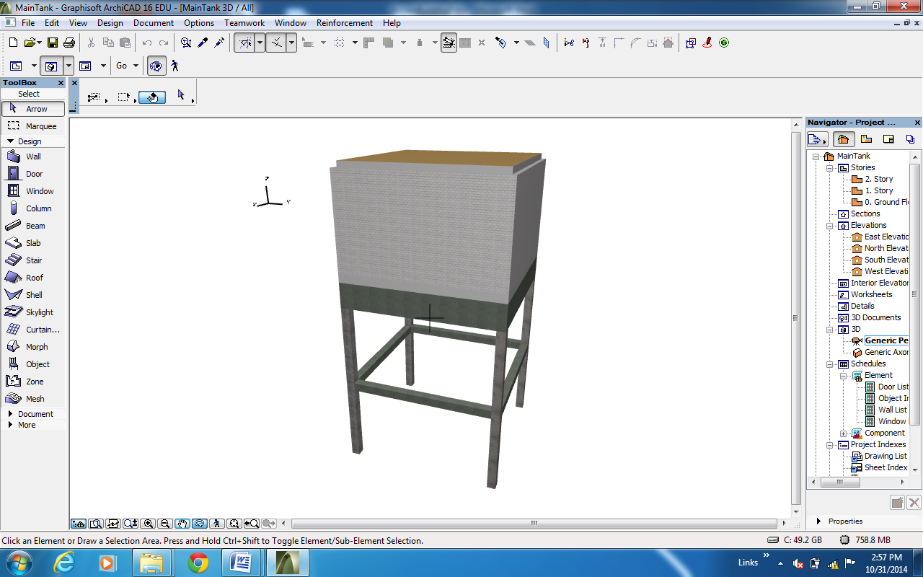

Figure 1 3D shaded view of Tank.

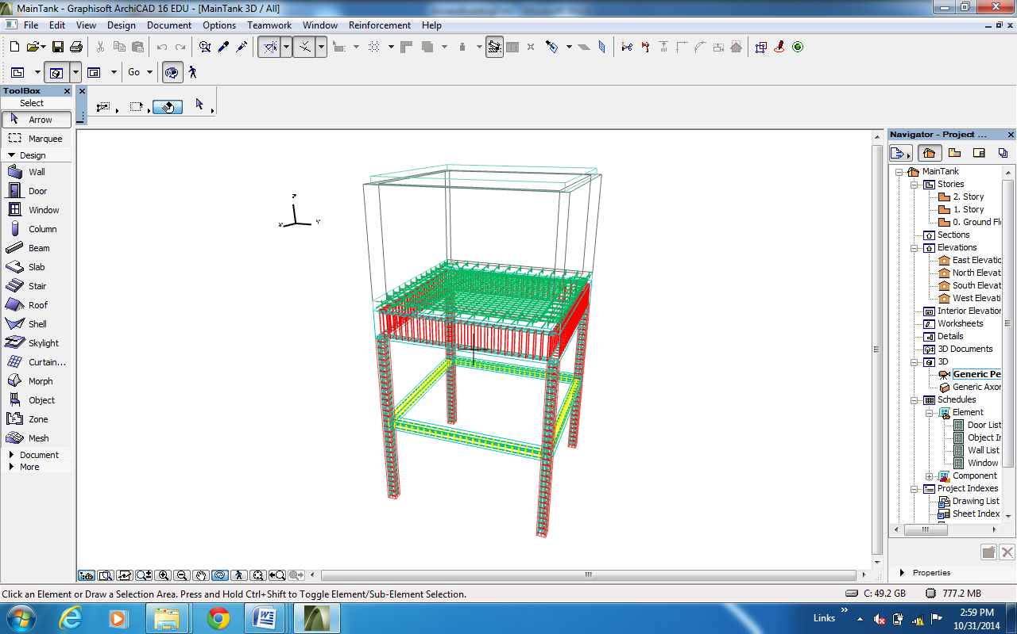

Figure 2 Wireframe tank model in ArchiCAD.

**5. IFC MAPPING**

On exporting, building data is mapped into ifc type and contain feature value as it exists in the real world. Like here Property, Pset_Column_common, contains the properties like Fire rating, placement ie External or internal, reference and slope of column. **Fig.3** illustrates the mapping of building data.

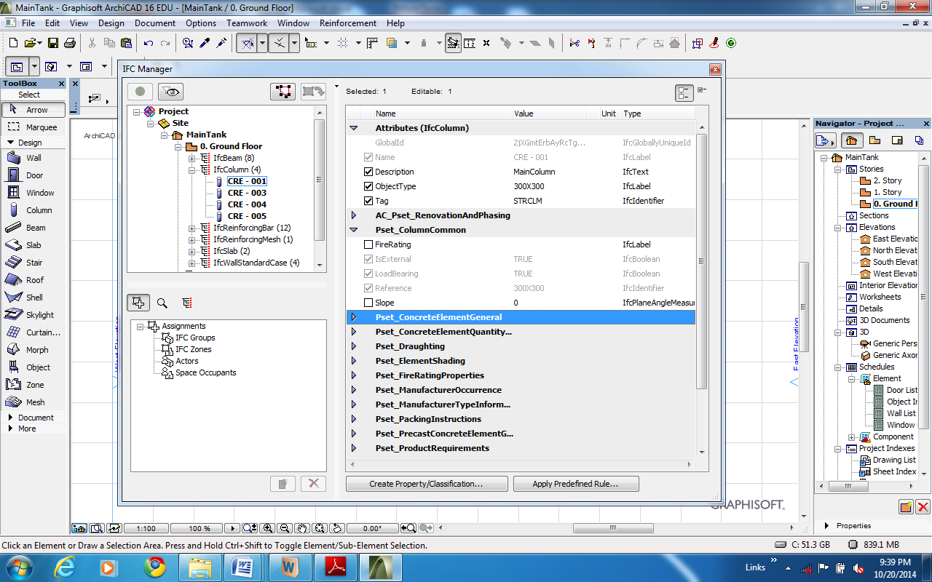

**Provide the Description,Objecttype Provide the Description,Ojecttype &Tag**

**Gives the property as**

1. **FireRating**
2. **IsExternal**
3. **LoadBearing**
4. **Reference**
5. **Slope**

**All above are properties of IfcColumn that is mapped into ifc as it is here.**

Figure 3 Mapping of properties of IfcElements in ArchiCAD in IFC type.

Fig.4 gives the idea of property sets and its containments like AC_Pset_RenovationandPhasing contains its data with complete detail of owner and organization.

Same property mapping is given below in Fig.5 for greater understanding.

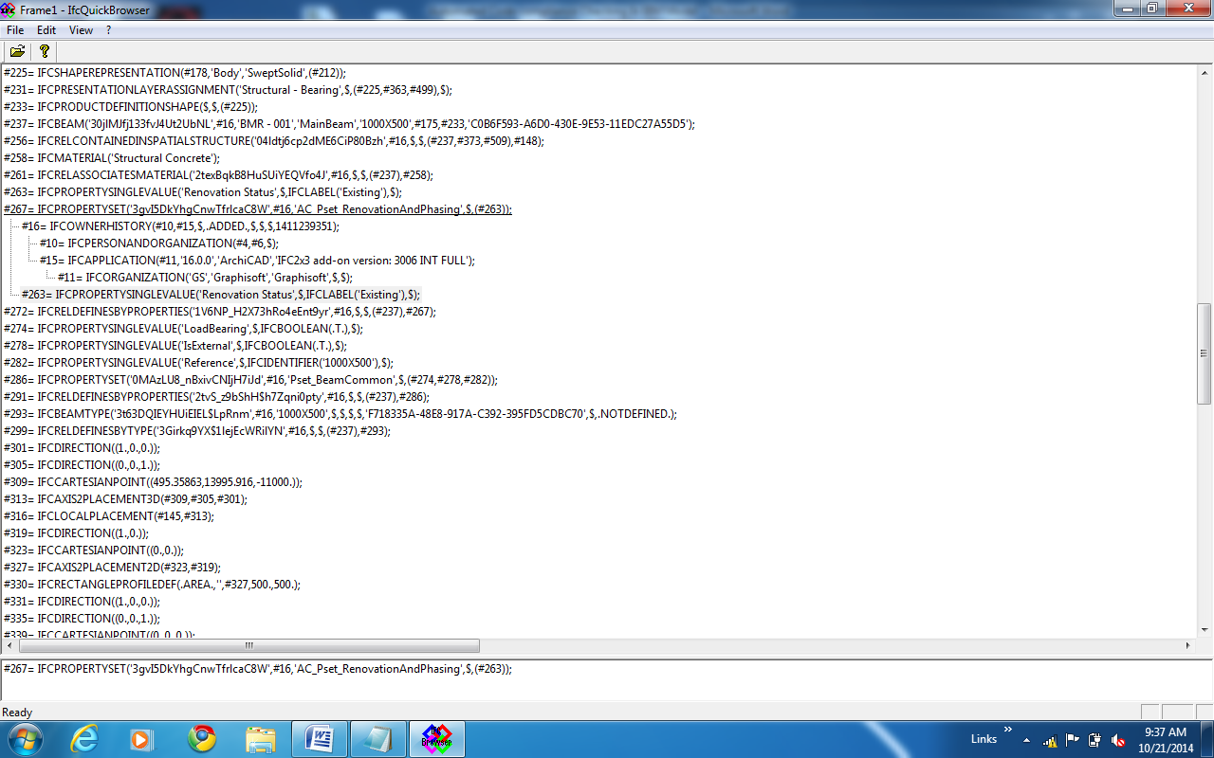

Figure 4 Snippet from IFC that shows a propertyset with its value and other contained information

Figure 5 shows the IfcProperties, and property definition that comes under IfcPropertySingleValue and its actual value type that comes under the definition of IfcLabel-wrapper as of here.

**PropertySet**

**Pset_RenovationAndPhasing**

**PropertyValue**

IfcPropertySingleValue

**Existing**

IfcLabel-wrapper

**HasPropert**y

IfcPropertySet

**6. IFC CONVERSION INTO ifcXML**

Data exported in the form of IFC,SPF converts into ifcXml in same order as it pertaining to IFC. **Fig 6** below gives the idea of conversion. In ifc SPF Format data entity have value shows with value otherwise represented as $ ie dollar sign that mean null value or no value is provided. New Entity in ifc are provided in ifcXML with id that is a non-numeric value, started with letter ‘i’. In ifc with entity may contain other entities are shown in ifcXML as childnode, and may contain ref value that refers to same entity in file with id. As in the fig shown IfcPerson that is a entity given in ifcXML with id and same entity is accessed in another entity IfcPersonOrganisation by ref value that is equals to the id of IfcPerson.

Figure 6 Conversion of .ifc to .ifcXML.

#4= IFCPERSON($,'Undefined',$,$,$,$,$,$);

#6= IFCORGANIZATION($,'Undefined',$,$,$);

#10= IFCPERSONANDORGANIZATION(#4,#6,$);

#11= IFCORGANIZATION('GS','Graphisoft','Graphisoft',$,$);

<IfcPersonid="i1541"> <FamilyName>Undefined</FamilyName></IfcPerson>

<IfcOrganizationid="i1543"> <Name>Undefined</Name>

</IfcOrganization>

<IfcPersonAndOrganization id="i1547">

<ThePerson>

<IfcPerson xsi:nil="true" ref="i1541"/>

</ThePerson>

<TheOrganization>

<IfcOrganization xsi:nil="true" ref="i1543"/>

</TheOrganization>

</IfcPersonAndOrganization>

<IfcOrganization id="i1548">

<Id>GS</Id>

<Name>Graphisoft</Name>

<Description>Graphisoft</Description>

</IfcOrganization>

For simplicity getting the meaning of conversion same color boxes are used to depict the conversion of an IFC(SPF) line into corresponding ifcXML format.

**7. Methodology**

IFC (SPF) data format, conforms to ISO-10303-21, automatically converts into ifcXML format, against ISO-10303-28, when exported as ifcXML. The ifcXML file contains entity property as id, ref/href that is non numeric. An entity with an ref or href should have no children except xsi:nil=”true” attribute ,that stop validation process objecting to the absence of mandatory element below. Any entity with local ref corresponds to another entity of the same type with matching id attribute. The ref attribute is used when reference element with all matching id resides within same ‘uos’ whereas href is used when matching id falls outside ‘uos’.

Here the relation of id and ref is used to fetch all the property, attribute of a structure component.IFC data type for each structural component and other required components are given by placing prefix Ifc then their usual name like Beam, Column etc... Some of components with ifc datatype are written as shown in table 1.

Table 1 : Ifc Elemets.

|  |  |
| --- | --- |
| Components | Ifc type |
| Beam | IfcBeam |
| Column | IfcColumn |
| Wall | IfcWall or IfcWallStandardCase |
| Slab | IfcSlab |
| ReinforcingBar | IfcReinforcingBar |
| Site | IfcSite |
| Storey Building | IfcStoreyBuilding |

To have access to complete data of Ifc model generated in BIM software IFC hierarchical order illustrated in figure 7 is employed, and to fetch the standard data like Geometric value of any building component at ifcbuildingstorey like column or IfcColumn, data flow shown in **Figures** below is used. From a main entity say IfcColumn starts reading the data and follow its attributes with childnodes if somewhere needed using ref switch to it entity with id value. **Fig.8** is snippet of ifc format that display the hierarchy or data flow for IfcColumn or Column. And same flow for ifcXML is also shown in **Fig.9** where piece of line of ifcXML arranged from top to bottom to represent the flow data of component, column as of here,

Figure 7 IFC hierarchical order

**IFC MODEL HIERARCHY**

IFC Project

IFC BuildingElement

IFC Site

IFC Building

IFC BuldingStorey

in order to have access to the data.

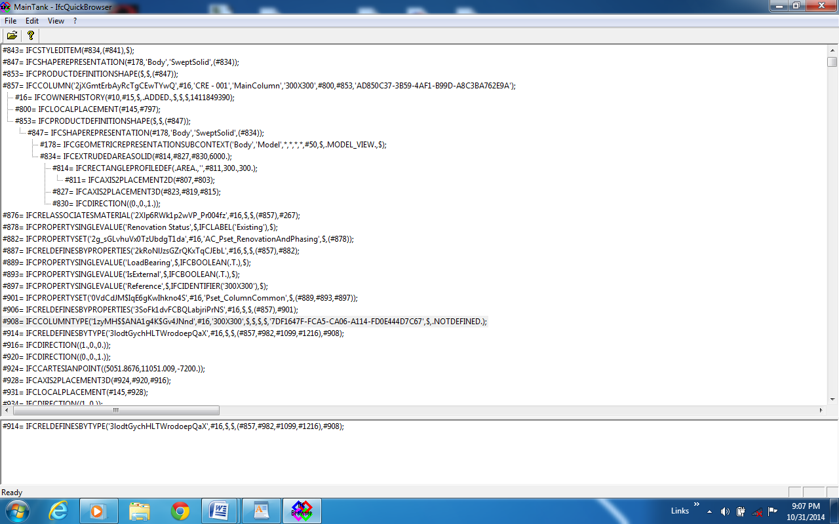

Figure 8 showing the building component IFCCOLUMN with its entities and values that it contained in ifc(SPF) format.

Figure 9 Hierarchy of Elements having entities, attribute and its value is shown for a Column.

<IfcColumn id="i2394">

<GlobalId>2jXGmtErbAyRcTgCEwTYwQ</GlobalId>

<OwnerHistory>

<IfcOwnerHistory xsi:nil="true" ref="i1553"/>

</OwnerHistory>

<Name>CRE - 001</Name>

<Description>MainColumn</Description>

<ObjectType>300X300</ObjectType>

<ObjectPlacement>

<IfcLocalPlacement xsi:nil="true" ref="i2337"/>

</ObjectPlacement>

<Representation>

<IfcProductDefinitionShape xsi:nil="true" ref="i2390"/>

</Representation>

<Tag>AD850C37-3B59-4AF1-B99D-A8C3BA762E9A</Tag>

</IfcColumn>

<IfcProductDefinitionShape id="i2390">

<Representations exp:cType="list">

<IfcShapeRepresentation exp:pos="0" xsi:nil="true" ref="i2384"/>

</Representations>

</IfcProductDefinitionShape>

<IfcShapeRepresentation id="i2384">

<ContextOfItems>

<IfcGeometricRepresentationSubContext xsi:nil="true" ref="i1715"/>

</ContextOfItems>

<RepresentationIdentifier>Body</RepresentationIdentifier>

<RepresentationType>SweptSolid</RepresentationType>

<Items exp:cType="set">

<IfcExtrudedAreaSolid xsi:nil="true" ref="i2371"/>

</Items>

</IfcShapeRepresentation>

<IfcExtrudedAreaSolid id="i2371">

<SweptArea>

<IfcRectangleProfileDef xsi:nil="true" ref="i2351"/>

</SweptArea>

<Position>

<IfcAxis2Placement3D xsi:nil="true" ref="i2364"/>

</Position>

<ExtrudedDirection>

<IfcDirection xsi:nil="true" ref="i2367"/>

</ExtrudedDirection>

<Depth>6000.</Depth>

</IfcExtrudedAreaSolid>

<IfcRectangleProfileDef id="i2351">

<ProfileType>area</ProfileType>

<ProfileName></ProfileName>

<Position>

<IfcAxis2Placement2D xsi:nil="true" ref="i2348"/>

</Position>

<XDim>300.</XDim>

<YDim>300.</YDim>

</IfcRectangleProfileDef>

Cross-Section of Column

Height of Column

Having the knowledge about data flow in ifcXML file, it is easier to work on the accessing the attribute values when working with the programming interface just by placing command of getting element having “id” and then checking its childnode, and its value, and if have “ref” attribute then switching to its entity having “id” attribute and then value is to be fetched. For all this a flow diagram is shown in figure 10.

Figure 10 Data flow and their access order with programming interface.

IfcShapeRepresentation

IfcExtrudeAreaSolid

IfcExtrudeAreaSolid

IfcShapeRepresentation

IfcRectangleProfileDef

IfcRectangleProfileDef

Have ref

Have id

Have ref

Have id

Have ref

Have id

Have ref

IfcProductDefinition

IfcProductDefinition

IfcColumn

Have id

Child denoted Children Tag and tag in oval give the data of the component like Depth, and Xdim and Ydim give height and cross-section of column. Similarly other data for building component can be accessed from ifcXML file and can be implemented against ISBC.

In Similar way properties of Elements can be accessed from file using the relation of “ref” and “id” given to different entities.

**8. DISCUSSION**

The scope of this paper is concerned with the IFC 2X3 and its equivalent XML based ifcXML format, and the conversion of real time building objects into IFC followed by further conversion to ifcXML. All this information lead to the accessing of the building data in a chronicle order. But working with the extruded viewpoint of object, as it is done in the paper, might be considered as the only limitation while rest of the process for other viewpoints, say BREP, will be same.

**8. Conclusion**

From above illustration it is very clear that using ifcXMl in spite of IFC work of data access for building model for further implementation and analysis is very lucid and fast resulting that will be quite helping to the learner in the field of building designing who can proceed with modeling without much knowing about ifc and its EXPRESS language. As ifcXML’s schema totally resembles to the XML, it is quite easy to collaborate it with any programming language without paying attention of its online API.

**REFERENCES**

1. External Product Library System – An Implementation of the Industry
2. Foundation Classes Release 2.0 Library Model by James Nyambayo, Robert Amor, Ihsan Faraj.
3. Graphisoft (2001) *ArchiCAD IFC Reference Guide,* Graphisoft.
4. buildingSMART (2009a)  *IFC2x Edition 3*.  Available at:<http://www.iai-tech.org/downloads/ifc/ifc2x3/IFC2x3_Final_HTML_distribution.zip/view> (Accessed: 28 May 2010).
5. buildingSMART (2009c)  *IFC Overview Summary* Available at:<http://www.iai-tech.org/products/ifc-overview>
6. buildingSMART ifcXML implementation guide .