**INTRODUCTION**

**OF**

**ENGINEERING**

**GURU NANAK DEV ENGINEERING & TECHNOLOGY**

**SUBMITTED TO: SUBMITTED BY:**

**Dr. H S RAI KULDIP SINGH**

**1524512**

**ENGINEERING**

Engineering is the applications of scientific, economic, social and practical knowledge in order to invent, design, build, maintain, research and improve structures, machines, devices, systems, materials and processes.

The term Engineering is derived from the Latin word ingenium meaning ‘cleverness’ and ingeniare meaning ‘to contrive device’.

Engineering combines the fields of Science and Maths to solve real world problems that improve the world around us.

One who practices Engineering is called an Engineer.

In old days, 1325 AD to be more precise an Engineer was defined as a constructor of Military engines. Back then Engineering was divided into two categories: Military Engineering & Civil Engineering.

**List of Engineering branches are:**

* Aerospace Engineering
* Chemical Engineering
* Civil Engineering
* Computer Engineering
* Electrical Engineering
* Information technology Engineering
* Industrial Engineering
* Mechanical Engineering
* Nanotechnology Engineering
* Nuclear Engineering
* Software Engineering
* System Engineering





**CIVIL ENGINEERING**

Civil Engineering is a branch of Engineering that deals with the design, construction and maintenance of the physical and naturally built environment including works like roads, bridges, canals, dams and buildings.

Civil Engineering is the second oldest Engineering discipline after Military Engineering and it is defined to distinguish non-military engineering from military Engineering.

The first Civil Engineering was an Englishman, John Smeaton in 1761, who constructed the Eddystone Lighthouse. John Smeaton is also called a father of Civil Engineering. Henry H. White, first Civil Engineering graduate from Bacon (Georgetown) college in 1840.

It is traditionally broken into several sub-disciplines including:

* Architectural Engineering
* Environmental Engineering
* Geotechnical Engineering
* Control Engineering
* Structural Engineering
* Earthquake Engineering
* Transportation Engineering
* Water resources Engineering
* Materials Engineering
* Waste water Engineering
* Quantity Surveying Engineering
* Construction & technology Engineering





**STRUCTURAL ENGINEERING**

Structural Engineering is the branch of Engineering which deals with the analysis, design, plan and research structural components and structural system to achieve design goals and ensure the safety and comfort of uses. Their work takes account mainly of safety, technical, economics and environmental concern but they may also consider aesthetic and social and social factors.

Structural Engineering has been in use since ages and one of the greatest ancient structures was the Pyramid of Giza in Egypt that was constructed in the 16th century BC.

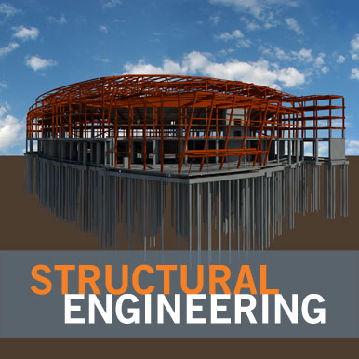 





**Fig. The Great Pyramid of Giza, Egypt**

**BUILDING**

A building is a man-made structures with a roof and walls standing more or less permanently in one place, such as a houses or factory.

Building comes in a variety of shapes, sizes and functions and have been throughout history for a wide number of factors from building materials available to weather conditions, to land prices, ground conditions, specific uses and aesthetic reasons.

Buildings serve several needs of society- primarily as shelter from weather, security, living space, privacy, to store belongings and to comfort live and work.

The materials are used in Construction of building is called a Building Materials and main building materials are:

* Cement
* Sand
* Aggregates
* Reinforcement
* Fiber
* Plastic
* Glass





**ANALYSIS**

Analysis is the process of breaking a complex topic or substance into smaller parts in order to gain a better understanding of it.

The technique has been applied in study of mathematics and logics.

Analysis is an independent subject was created as part of the scientific revaluation in the 17th century Kepler, Galileo, Fermat, Newton and Leibniz to its genesis.

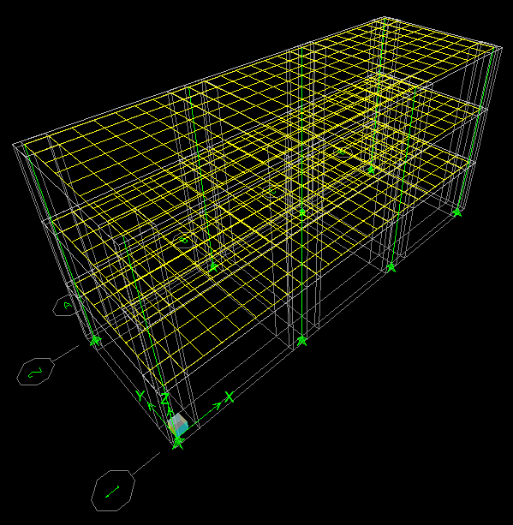

**DESIGN**

Design is a creation of a plan or convention for the construction of an object or a system. Design has different means in different field. In some cases the direct construction of an object is also considered to be design.

A plan or drawing produced to show the look and function or working of a buildings, garment or other object before it is made.

