Civil Engineering Department

Guru Nanak Dev Engineering College, Ludhiana

M.Tech 1st year MTST-602 Finite Element Methods

Date: Mon 19 Oct 15 2nd House Test Time: 10:30 a.m. to 12:00 noon Max. Marks 30

Don't write anything on question paper except your Roll No. _____________

1 | Derive stiffness matrix for plane strain case. | 10
2 | Determine displacement components and rotation under applied load for a rigid frame shown below. Let E = 210 GPa, I = 200 mm⁴ and A = 6000 mm² for each element. Both the supports are fixed.  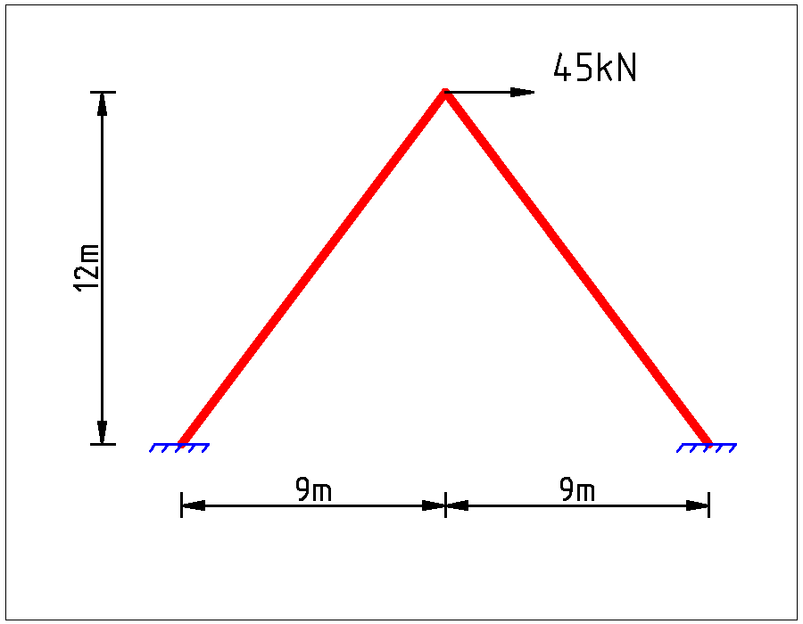 | 10
3 | What care should be taken while preparing a model for Finte Element Analysis, with respect to mesh size, aspect ratio of element, variation in size over domain? How one should check model before analysis, verify results after analysis and how one should take care of convergence? | 10

#####

