Civil Engineering Department

Guru Nanak Dev Engineering College, Ludhiana

M.Tech 1st year MTST-602 Finite Element Methods

Date: Tue 15 Sep 15 1st House Test Time: 10:30 a.m. to 12:00 noon Max. Marks 30

Don't write anything on question paper except your Roll No. _____________

1(a) | Name any five software which make use of Finite Element Method in their solver. Write down features and limitations of any one. | 4
1(b) | Write down steps involved in Finite Element Method. | 6
2 | Determine displacement (of truss shown below) in vertical direction at lower node and the axial force in each element, using Direct Stiffness Method of Finite Element. A force of P = 1000 kN is applied, as shown, and same node is displaced by an amount= 50 mm towards left side. Let E = 210 GPa and A = 600 mm² for each element.  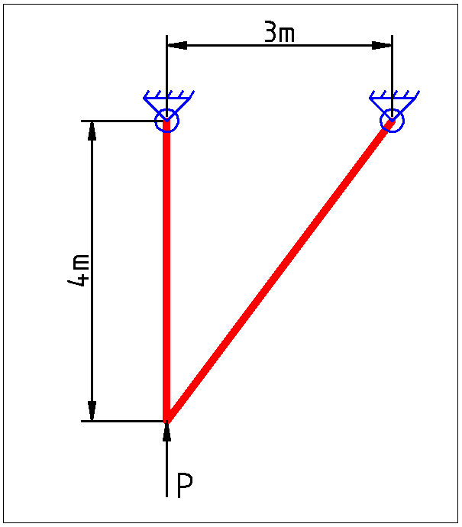 | 10
3 (a) | Derive stiffness matrix for Spring Element using potential energy approach. | 5
3 (b) | Find Global Stiffness Matrix for a two span continuous beam. Both spans of beam have constant El and have same span length. | 5

#####

